- 小希的数表：
运行结果截图：
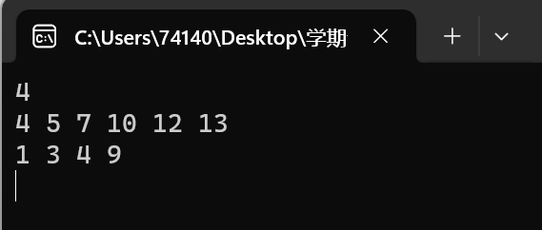
程序代码：#include <iostream>
#include <vector>
using namespace std;

int main() {
int n;
while (cin >> n && n) {
int all = n * (n - 1) / 2;
vector<int> sum(all);

for (int i = 0; i < all; ++i) {
cin >> sum[i];
}

for (int k = 2; k < all; ++k) {
vector<int> num(n + 5, 0);
vector<bool> vis(all, false);

if ((sum[0] + sum[1] - sum[k]) % 2 || (sum[0] + sum[1] - sum[k] <= 0))
continue;

num[0] = (sum[0] + sum[1] - sum[k]) / 2;
num[1] = (sum[0] - num[0]);
num[2] = (sum[1] - num[0]);
vis[0] = vis[1] = vis[k] = true;

int know = 2;
bool flag = true;

while (know != n - 1) {
int in = -1;
for (int i = 0; i < all; ++i) {
if (vis[i] == false) {
in = sum[i];
vis[i] = true;
break;
}
}

num[++know] = in - num[0];

for (int i = 1; i < know; ++i) {
int he = num[know] + num[i];
flag = false;

for (int j = 0; j < all; ++j) {
if (vis[j] == false && sum[j] == he) {
vis[j] = true;
flag = true;
break;
}
}

if (flag == false) break;
}

if (flag == false) break;
}

if (know != n - 1) continue;

for (int i = 0; i < n; ++i) {
cout << num[i] << ' ';
}
cout << endl;
break;
}
}

return 0;
}

2变形课：
运行结果截图：
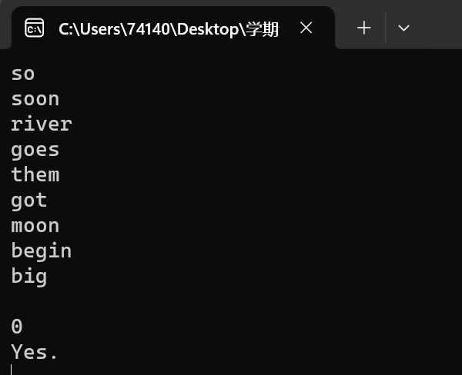
程序代码：#include <iostream>
#include <string>

using namespace std;

bool canTransform(string spells[]) {
for (int i = 0; spells[i] != "0"; ++i) {
if (spells[i][0] == 'b' && spells[i][spells[i].length() - 1] == 'g') {
return true;
}
}
return false;
}

int main() {
while (true) {
string spells[100];
int idx = 0;

while (true) {
cin >> spells[idx];
if (spells[idx] == "0") {
break;
}
idx++;
}

if (spells[0] == "0") {
break;
}

if (canTransform(spells)) {
cout << "Yes." << endl;
}
else {
cout << "No." << endl;
}
}

return 0;
}

3. Gizilch
运行结果截图：
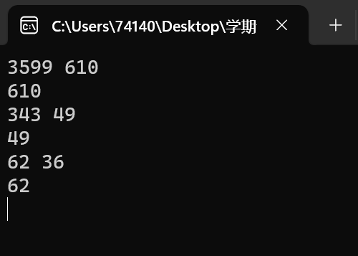

程序代码：#include<iostream>
#include<cstdio>
#include<cstring>
using namespace std;

int flag;
int fuck;
int maxx;
int minn;
int f[101];

int dfs(int t)
{
if (t == 1)
{
if (flag == 0)
{
fuck = 1;
flag = 1;
if (dfs(maxx)) return 1;
else
{
flag = 0;
return 0;
}
}
return 1;
}
int len = 100 < t ? 100 : t;
for (int i = 2; i <= len; i++)
{
if (t % i == 0 && f[i] == 0)
{
f[i] = 1;
if (dfs(t / i)) return 1;
f[i] = 0;
}
}
return 0;
}
int main()
{
int x, y;
while (scanf_s("%d%d", &x, &y) != EOF)
{
int ans;
flag = 0;
fuck = 0;
maxx = max(x, y);
minn = min(x, y);
memset(f, 0, sizeof(f));
int tt = dfs(minn);
if (fuck == 0) ans = maxx;
else if (fuck == 1 && tt == 1) ans = maxx;
else ans = minn;
printf("%d\n", ans);
}
return 0;
}

4.Tempter of the Bone
运行截图：
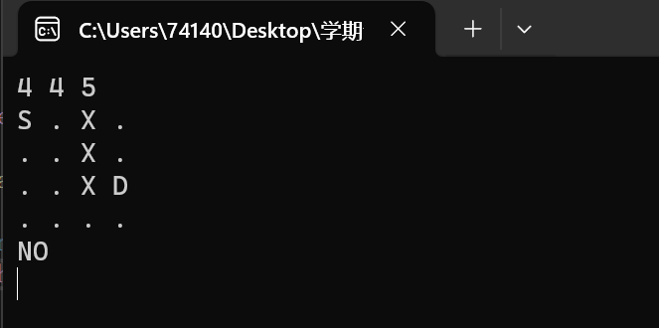
程序代码：#include<string.h>
#include<stdio.h>
#include<iostream>
#include<stdlib.h>
using namespace std;
char maze[7][7];
int direct[4][2] = { {0,1},{0,-1},{1,0},{-1,0} };
int n, m, t, dx, dy;
bool flag;
void dfs(int x, int y, int step)
{
int i, p, x1, y1;
if (x <= 0 || x > n || y <= 0 || y > m)
return;
if (x == dx && y == dy && step == t)
{
flag = 1;
return;
}
p = (t - step) - abs(x - dx) - abs(y - dy);
if (p < 0 || p & 1)
return;
for (i = 0; i < 4; i++)
{
x1 = x + direct[i][0];
y1 = y + direct[i][1];
if (maze[x1][y1] != 'X')
{
maze[x1][y1] = 'X';
dfs(x1, y1, step + 1);
if (flag)
return;
maze[x1][y1] = '.';
}
}
return;
}
int main()
{
int i, j, sx, sy, wall;
while (scanf_s("%d%d%d", &n, &m, &t) && (m + n + t))
{
wall = 0;
for (i = 1; i <= n; i++)
{
for (j = 1; j <= m; j++)
{
cin >> maze[i][j];
if (maze[i][j] == 'S')
{
sx = i;
sy = j;
}
else if (maze[i][j] == 'D')
{
dx = i;
dy = j;
}
else if (maze[i][j] == 'X')
wall++;
}
}
flag = 0;
maze[sx][sy] = 'X';
dfs(sx, sy, 0);
if (n * m - wall <= t)
{
printf("NO\n");
continue;
}
if (flag)
printf("YES\n");
else
printf("NO\n");
}
return 0;
}

7．N皇后问题：
运行截图：
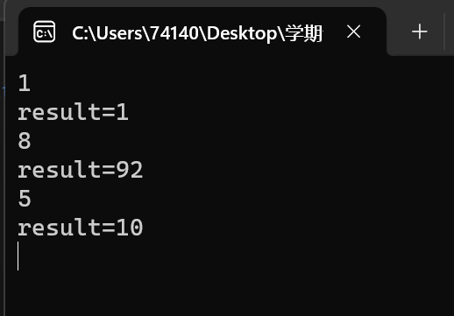
程序代码：#include <iostream>
#include <cmath>
using namespace std;

// 判断在当前位置放置皇后是否合法
bool isSafe(int board[], int row, int col, int n) {
// 检查列是否有皇后
for (int i = 0; i < row; ++i) {
if (board[i] == col || abs(board[i] - col) == abs(i - row)) {
return false;
}
}
return true;
}

// 递归函数，尝试在当前行放置皇后
void solveNQueens(int board[], int row, int n, int& count) {
if (row == n) {
// 找到一种放置方式
count++;
return;
}

for (int col = 0; col < n; ++col) {
if (isSafe(board, row, col, n)) {
// 在当前位置放置皇后
board[row] = col;
// 递归放置下一行的皇后
solveNQueens(board, row + 1, n, count);
}
}
}

int main() {
while (true) {
int n;
cin >> n;
if (n == 0) {
break;
}

int count = 0;
int* board = new int[n]; // 使用动态分配数组
solveNQueens(board, 0, n, count);
delete[] board; // 释放动态分配的数组
cout << "result="<<count<<endl;
}

return 0;
}

